[LOCATION] – [BUILDING NAME]
[Required] Services

Street Address: [ ]

Pre-Bid Meeting: [Month Day, Year], [ ] [a.m.][p.m.]
[place]

Bid Closing Date and Time: [Month Day, Year], at 2:00:00 p.m.

Inquires Contact: [Name]@gov.ab.ca (include the Plan No. in the subject line).

Building No: [ ]

Plan No.: [

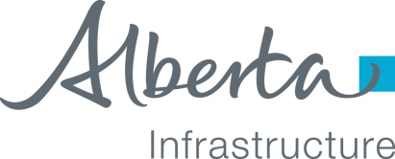

[LOCATION] – [BUILDING NAME]
[Required] Services

Building No: [ ]

Plan No.: [ ]

Specifier:

Properties Division
Property Management
Alberta Infrastructure
6950 - 113 Street NW
Edmonton, Alberta T6H 5V7

1. LIST OF SPECIFICATION SECTIONS

Section Section
Division Number Name

Spec Note: The Sections identified below are from the Property Management Services Master Specification in the Technical Resource Center (TRC) unless noted with (BMS). These Sections are normally always used and are located in the Basic Master Specification on the TRC. Edit the BMS Sections as required.

DIVISION 00 – PROCUREMENT AND CONTRACTING REQUIREMENTS

Instructions for
Procurement 00 21 14 Instructions to Bidders
00 25 13 Pre-Bid Meeting (BMS)

Procurement and 00 40 41 Unit Price Bid and Contract Form
Contract 00 61 56 Fidelity Bond
Requirements 00 72 10 General Conditions of Contract
00 73 90 Public Works Act Claims (BMS)
00 73 90A Statement of Public Works Act Claim (BMS)

DIVISION 01 – GENERAL REQUIREMENTS

General 01 00 15 General Requirements
Requirements 01 21 13 Cash Allowances (BMS)
01 21 16 Contingency Allowance
01 35 14 Project Security and Safety Procedures (BMS)

Spec Note: List Property Management Services Master Specification Sections or BMS Technical Sections below and use as required, or keep ‘Not Used’
DIVISIONS 02-48 ‘Not Used’

END OF TABLE OF CONTENTS

