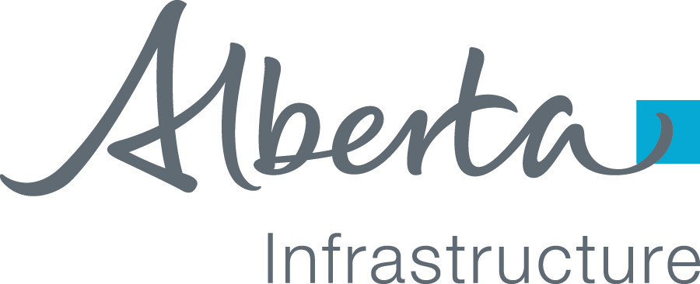

 | 2nd Floor, Infrastructure Building | Phone : 780-422-0616
 | 6950-113 Street N.W. | Fax: 780-638-4158
 | Edmonton, Alberta  Canada T6H 5V7 | Toll Free  Outside Edmonton Dial:310-0000  www.infrastructure.alberta.ca

Month Day, Year
Project ID:

Ms. Penny Rae, Senior Vice President
Capital Management
Alberta Health Services
10301 Southport Lane S.W.
Calgary AB T2W 1S7

Dear Ms. Rae:

Re: PROJECT LOCATION AND BUILDING NAME and contract title
Facility Handover Date

I am writing with respect to {Project Name} to confirm the Handover Date and occupancy of the new facility by Alberta Health Services (AHS) effective {Enter Date}, as discussed with your AHS team. This letter will serve as our confirmation and your agreement of various aspects respecting the handover.

Please review and if you are in agreement with the content, please sign, date and return the signed letter to {Project Director}, at the above address.

- Insurance:

- Warranties:

- Manuals and Record Drawings:

- Completion of Prime Contractor Responsibilities:

- Operations and Maintenance of the Building and Site:

- Disposition of Surplus Equipment and Materials:

- Contractor Installation of Furnishing and Equipment Related Items:

Page 1 of 3
- Presence of Alberta Infrastructure and Construction Staff on Site:

We are pleased to hand over this facility to ASHS, and appreciate the on-going support and assistance from yourself and AHS staff. Should you have any questions with respect to the above, please contact {Project Director}, {Phone Number}.

Sincerely,

Brian Fedor
Executive Director

cc: Zone Capital Management (VP/ED), Alberta Health Services
Brian Fedor, Executive Director, Health Facilities Branch, Alberta Infrastructure
Project Director, Health Facilities Branch, Alberta Infrastructure
Jacquie Rocheleau, Alberta Treasury Board and Finance
David Breakwell, Alberta Health

Agreed Date
Penny Rae, Senior Vice President
Capital Management, Alberta Health Services

Page 3 of 2

